Clinical evaluation of PETRACKR® point of care blood glucometer for dogs and cats
Dr. Marcin Kowalczyk, Ms. Jamie Peterson Universal Biosensors, 1 Corporate Avenue, Rowville VIC 3178 Australia. Dr. Kellie M. Cammarano, Dr. Jennifer M. Prieto, Dr. John P Loftus, Cornell University College of Veterinary Medicine, Ithaca NY 14853 USA.
Diabetus melletus is an increasingly common condition among companion cats and dogs. Clinical management of this condition requires constant monitoring wherein handheld glucometers are the mainstay. This study describes the clinical evaluation of PETRACKR handheld glucometer for cats and dogs assessed against a laboratory biochemical analyser reference. It was found that 95% of PETRACKR results are in accordance with international accuracy standards for human glucometers (ISO15197:2013).

- Introduction
Diabetes mellitus is a relatively common endocrinopathy in cats and dogs affecting approximately 0.6% and 0.3% of the total population of each species respectively. In the United States, approximately 48 million households are registered as dog owners and 32 million households own cats. Unfortunately, diabetes is becoming more common as instances of pet obesity also increase.,, Although underlying aetiologies differ between the two species, both are treated with exogenous insulin and require regular monitoring to ensure appropriate therapy.
Laboratory biochemistry analysers remain the mainstay for measuring blood glucose and hence diagnosis of this condition. However, monitoring options for pet guardians are dominated by portable blood glucometers which provide affordable and convenient point-of-care (POC) use. While animal coded portable glucometers have more recently become available on the market, the use of human glucometers remains common despite their unvalidated status in this application. Further, leading brand pet coded blood glucometers such as the AlphaTrak2® investigated by peer review show limitations wherein only 50% of samples are within ISO15197:2013 accuracy specifications. This type of inaccuracy has potential dangerous consequences for the patient and so a need exists for a more reliable system.
The present study compares the performance of the PETRACKR blood glucometer for dogs and cats against a laboratory instrument as a reference device. A wide range of blood glucose concentrations in diabetic and non-diabetic animals are included in this study.
- Materials and Methods

Animals
A total of 56 individual dogs and 54 individual cats admitted for medical intervention and care for diabetic and non-diabetic conditions requiring a blood draw were selected as participants for this study. Animals who provided a sample with a hematocrit outside of a range of 20 – 60% were excluded.
  - Sample Collection and Test Protocols
Approximately five millilitres of blood was drawn from the jugular, saphenous or cephalic vein using a sterile 28 gauge needle and syringe. The site of the blood draw was selected for animal and phlebotomist safety and comfort and was not anticipated to affect the result. Freshly drawn blood was immediately tested on the PETRACKR system in duplicate (requiring 0.7 µL of blood per test). The first drop was used to estimate the accuracy of the PETRACKR glucometer and the second used to estimate the system reproducibility. The remainder of the blood was used in diagnostic testing for the animals own medical condition but included a plasma-equivalent glucose concentration determination on the Roche Cobas® c501 Biochemistry Analyser.
  - Blood Glucometers and Reference Methods
The PETRACKR blood glucometers were prepared by testing with a commercially available control solution before any subsequent testing to ensure they were working as expected. Testing occurred by applying whole blood to the test strip when prompted by the device. The measuring range of the device is 20 – 600 mg/dL. The samples were centrifuged within 5 mins of blood draw and the plasma was analysed on the Roche Cobas c501 Biochemistry Analyser. The Cobas biochemistry analyser was calibrated weekly with commercial reagents, with two-point commercial control solutions run daily.
  - Statistical Analysis and Acceptance Criteria
The PETRACKR system was evaluated with respect to accuracy as per ISO15197:2013 standards for human blood glucometers. These standards mandate that 95% of samples should fall within 15 mg/dL for glucose concentrations of ≤ 100 mg/dL or 15% above of this range. The risk of any inaccuracies was evaluated against Parkes Consensus Error Grid. This divides any method comparison into zones A – E, with each zone indicating a different risk profile to the patient (see figure 3).
Regression statistics were generated by Analyse-It plugin (v. 5.66) for Microsoft Excel using Ordinary Deming Regression at the 95% confidence interval and the 5% significance level.

Results and Discussion
3.1 Method Comparison and Regression Analysis
The population distribution of participants of this study was found to be asymmetric with a mean value just above the normal blood glucose range in these animals (Figure 1).
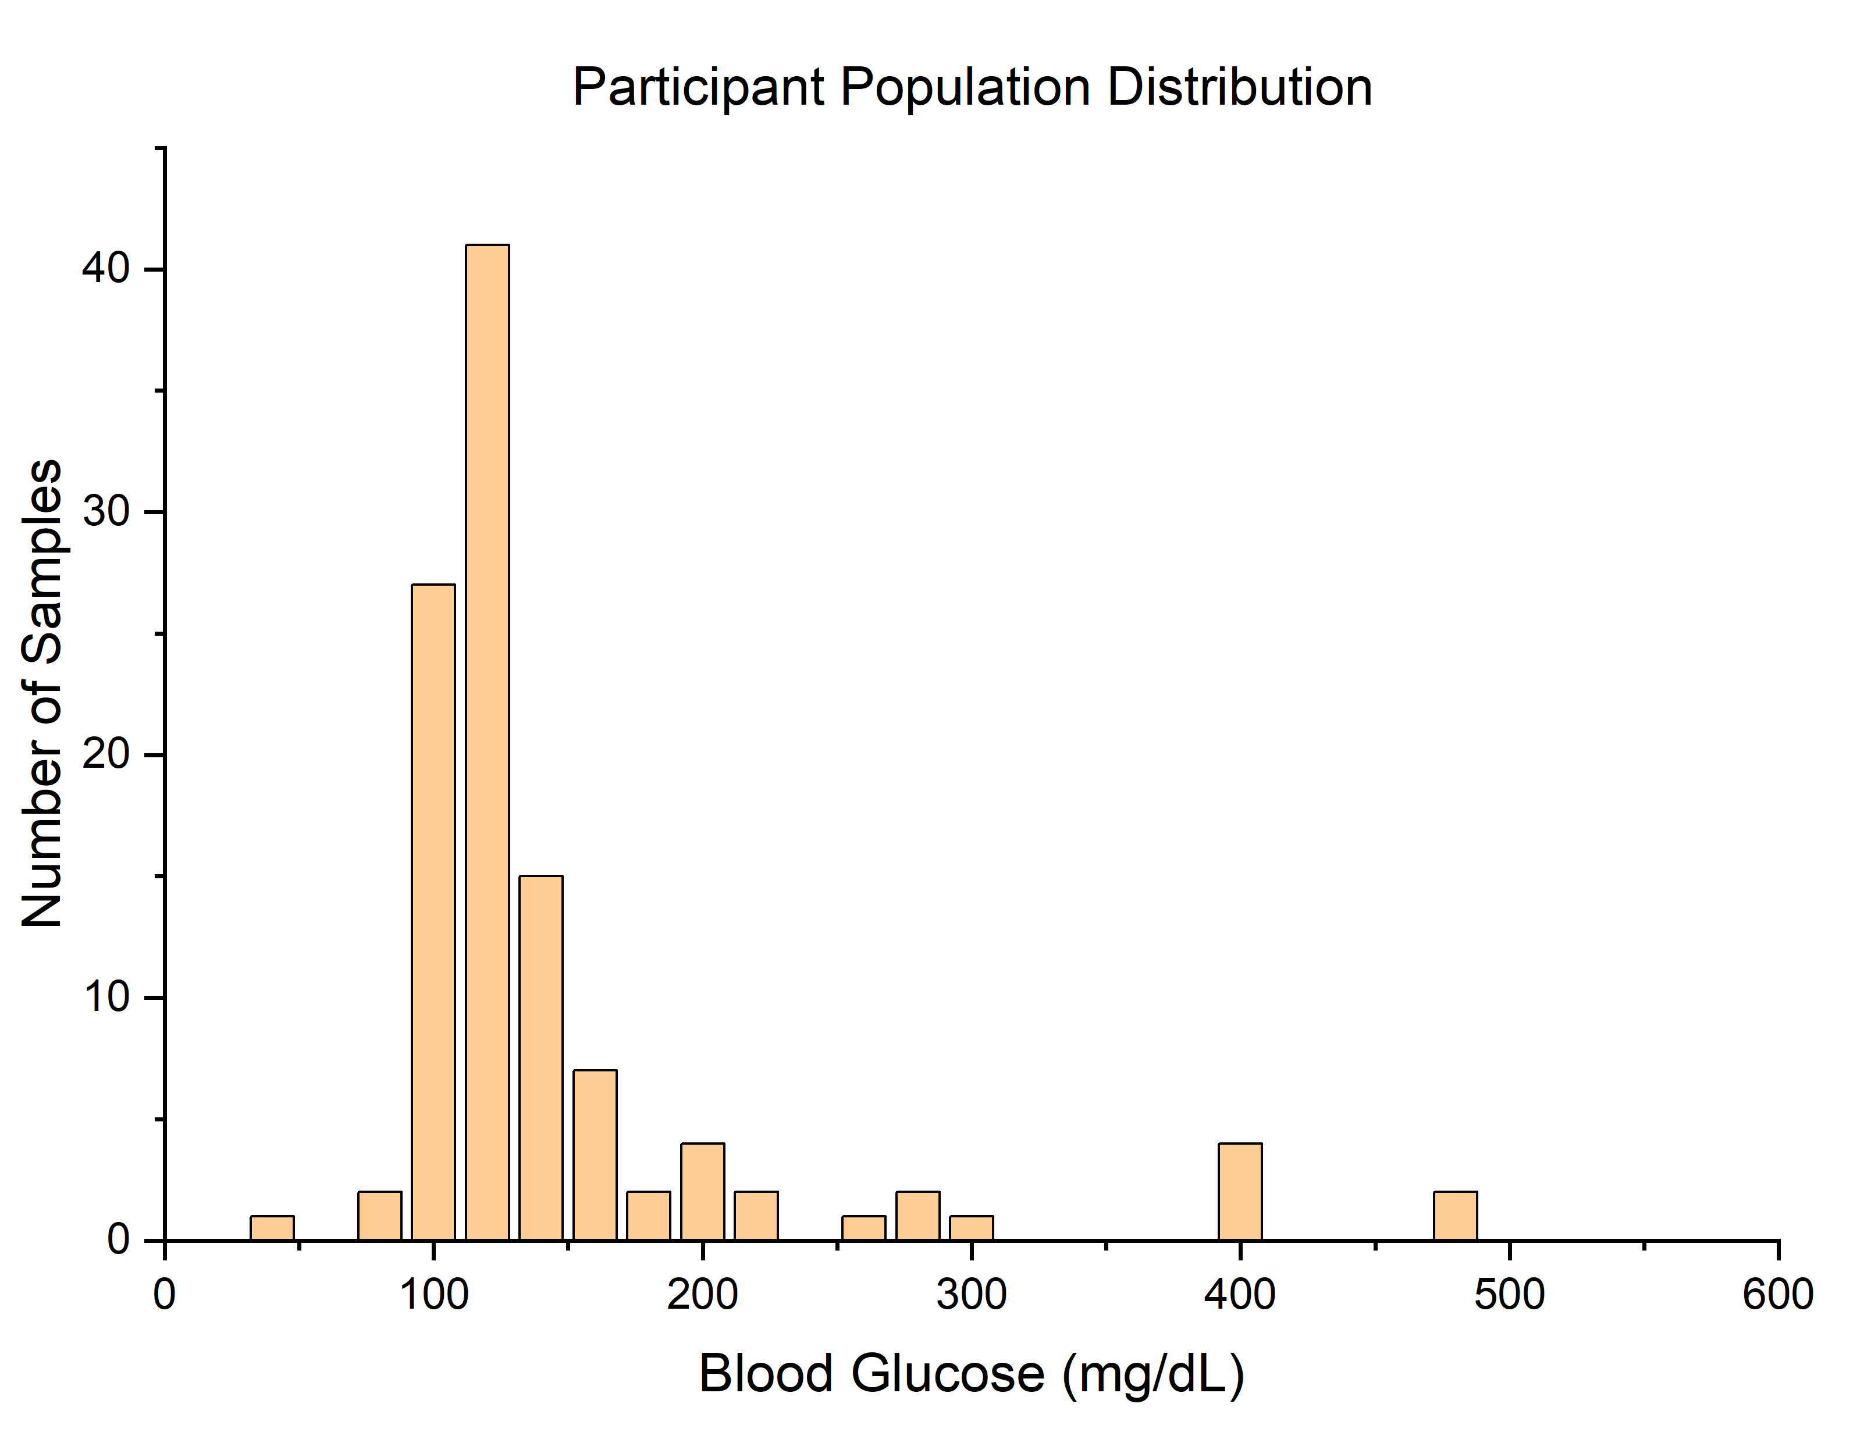
Figure 1 – Blood glucose sample distribution shows the majority of samples are within the normal blood glucose range.
The lack of an even distribution of samples along the measuring range of the device are a limitation of this population demographic. Despite this, a significant amount of samples within the critical normal blood glucose range provide excellent confidence in assessing the performance of the device without significantly increasing the difficulty of the study. Furthermore, at these normal blood glucose concentrations, the zone of the Parkes consensus error grid are close to each other such that small inaccuracies can result in altered clinical action (figure 3). Therefore it is critical that the study contains sufficient samples in this region to properly assess patient risk.
A comparison of the PETRACKR result with the reference analyser is shown in Figure 2. Of the population tested, 104 samples were found to fall within the ISO15197:2013 specifications for accuracy (95%).

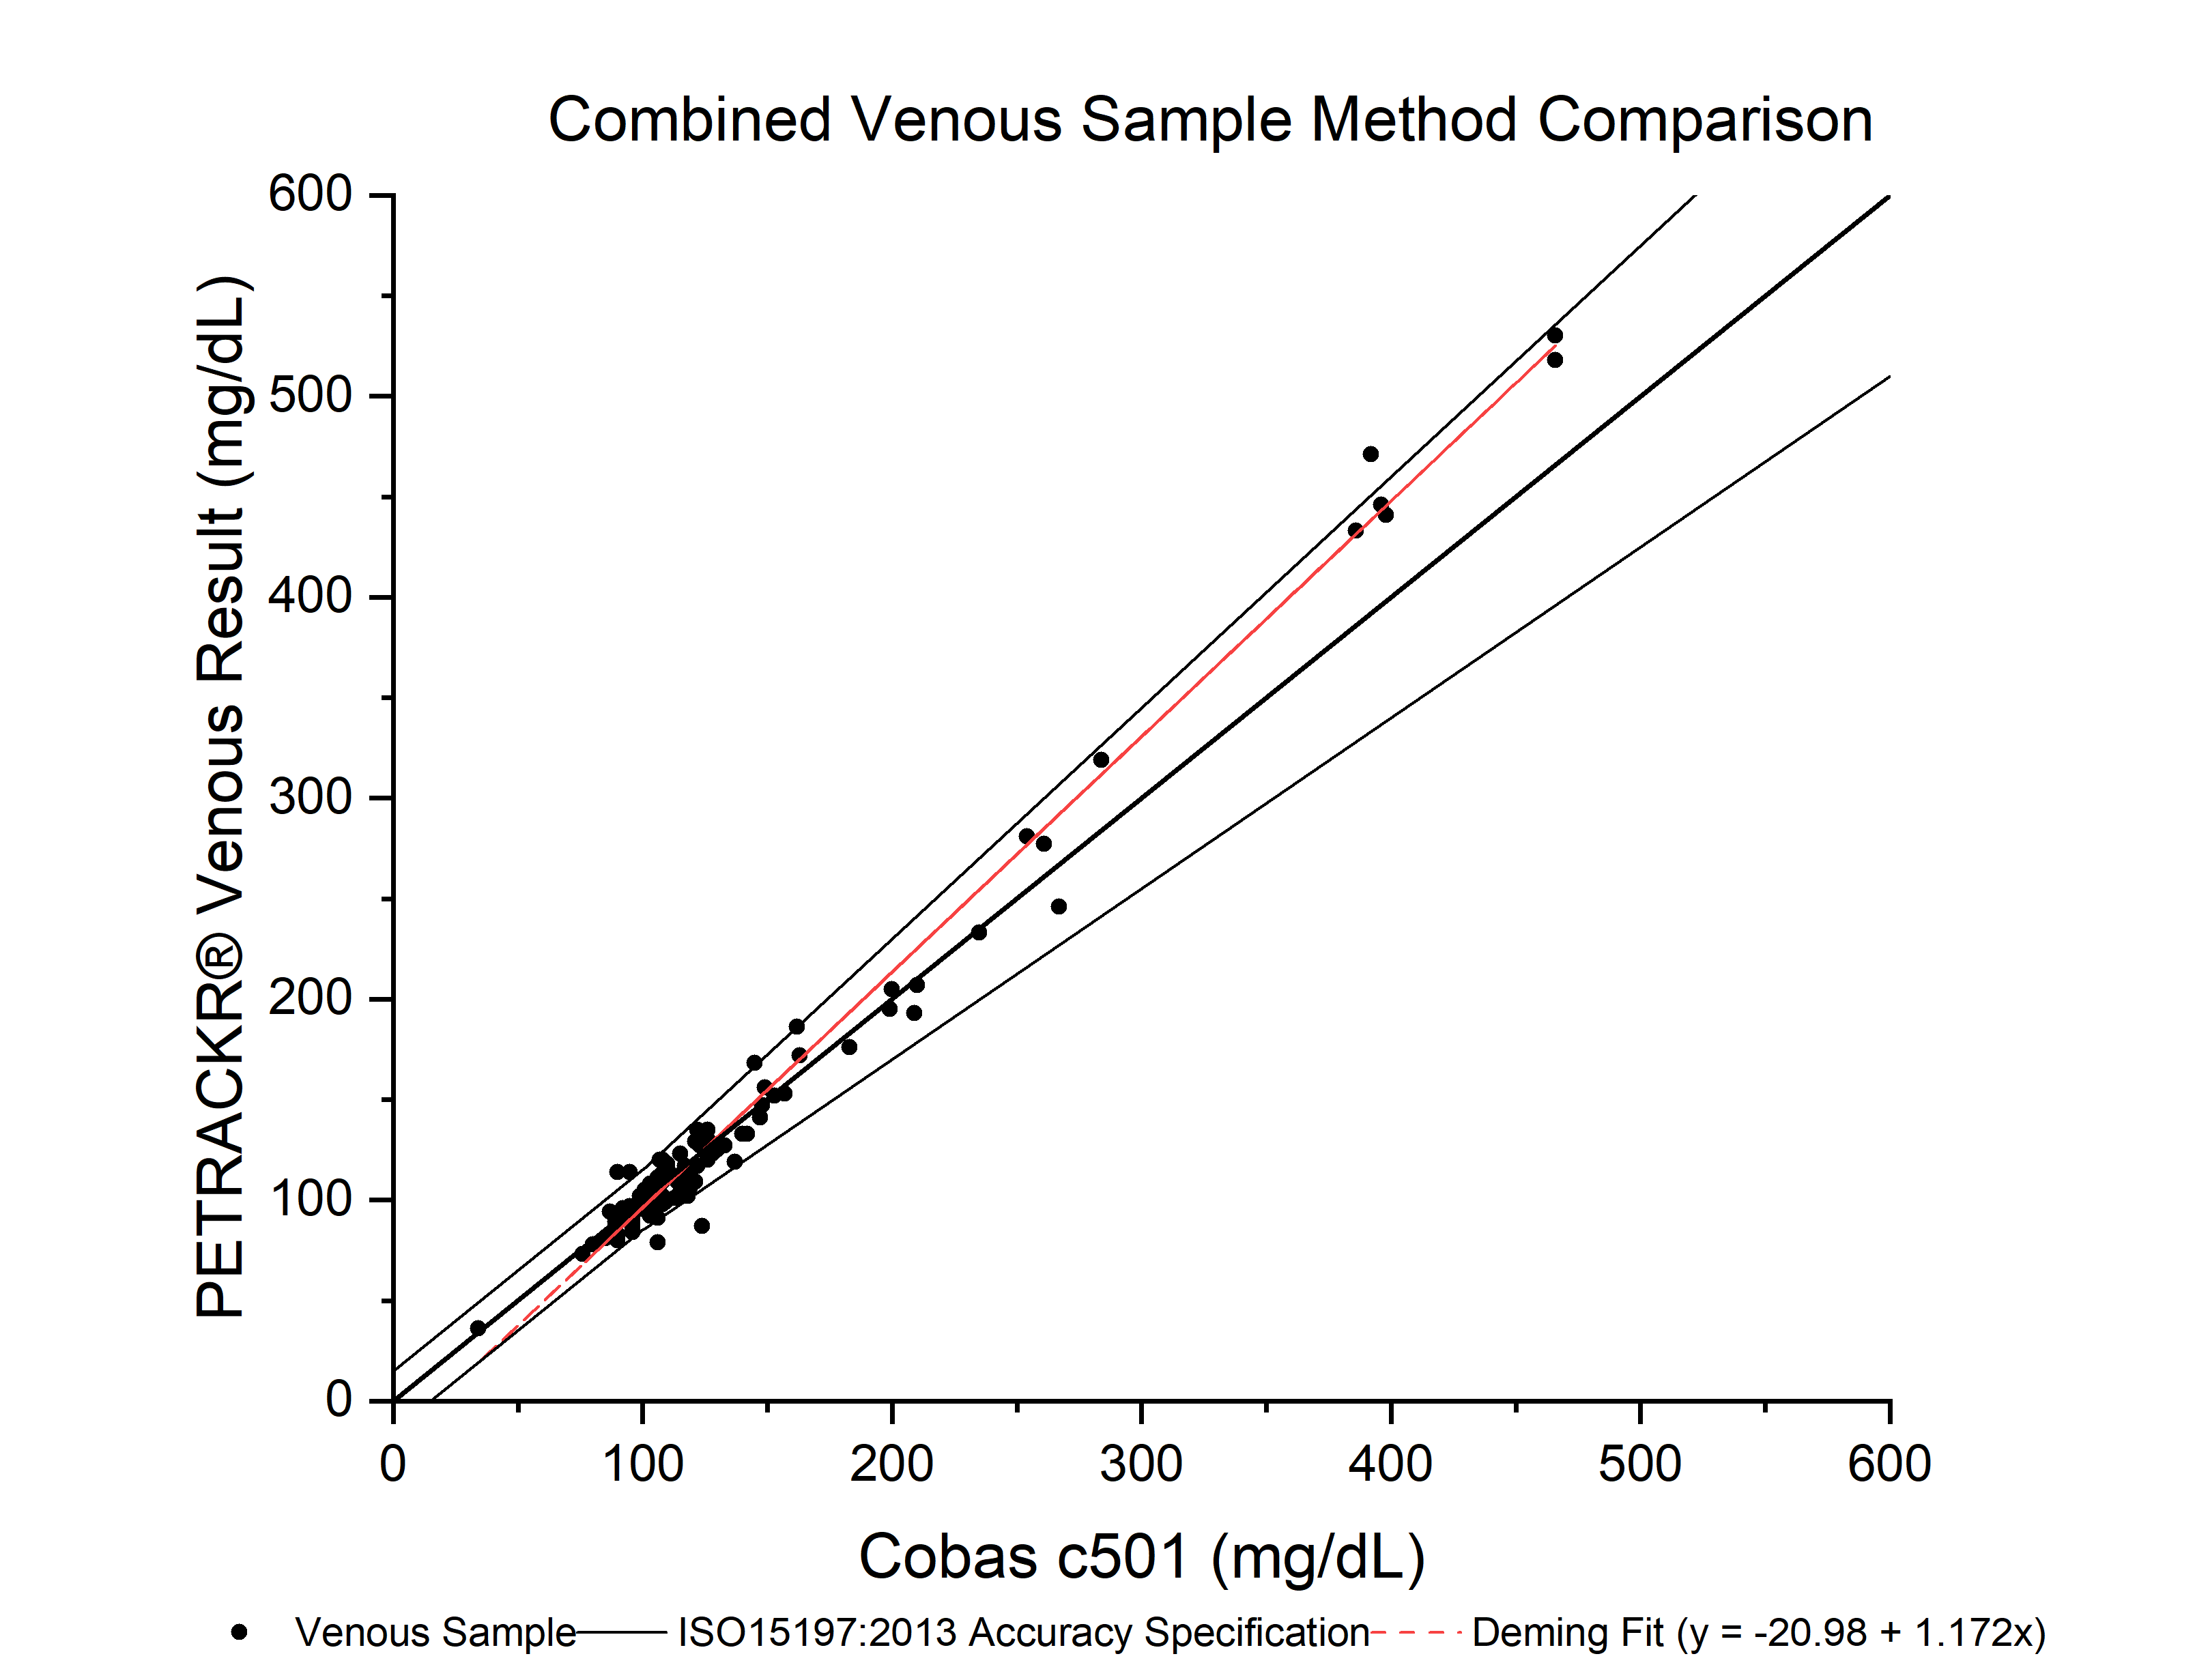
Figure 2 – Method comparison curve between the Roche Cobas c501 reference analyser and the PETRACKR blood glucometer. The y=x line, linear regression and ISO15197:2013 accuracy specifications have been superposed.
The system reproducibility was also calculated and is presented in table 1 along with regression statistics for this method comparison. Note that the PETRACKR system does not require the user to differentiate between cats and dogs and no differences in the response to these populations was observed in this study.
Table 1 – Regression statistics and standard deviation between replicates summary table.
Statistic | Value
Pooled standard deviation between replicates | 4.19 mg/dL
Slope (95% CI using Ordinary Deming Regression) | 1.137 to 1.206
y-intercept (95% CI using Ordinary Deming Regression) | -25.19 to -16.78
R² | 0.99
The data shows that the PETRACKR correlates well to the Cobas reference device in this study (R²). A small number of data points were shown to be outside the ISO15197:2013 accuracy specification. The points at 400 mg/dL and above exhibit a high bias overall however more data is required to form a conclusion about any systematic bias of the device at this range.
The result distribution was also plotted on Parkes Consensus Error Grid to evaluate the risk of observed inaccuracies of the meter to the patient (Figure 3).¹⁰ Parkes error grid was published in 2000 based on a survey of 100 physician attendees at the June 1994 American Diabetes Meeting. It is intended an alternative to the Clarke grid which has been criticised for its placement of risk boundaries.¹¹ Herein it was observed that only 1 sample (0.9% of samples) fell within zone B of the grid and the remining 99.1% was within zone A.
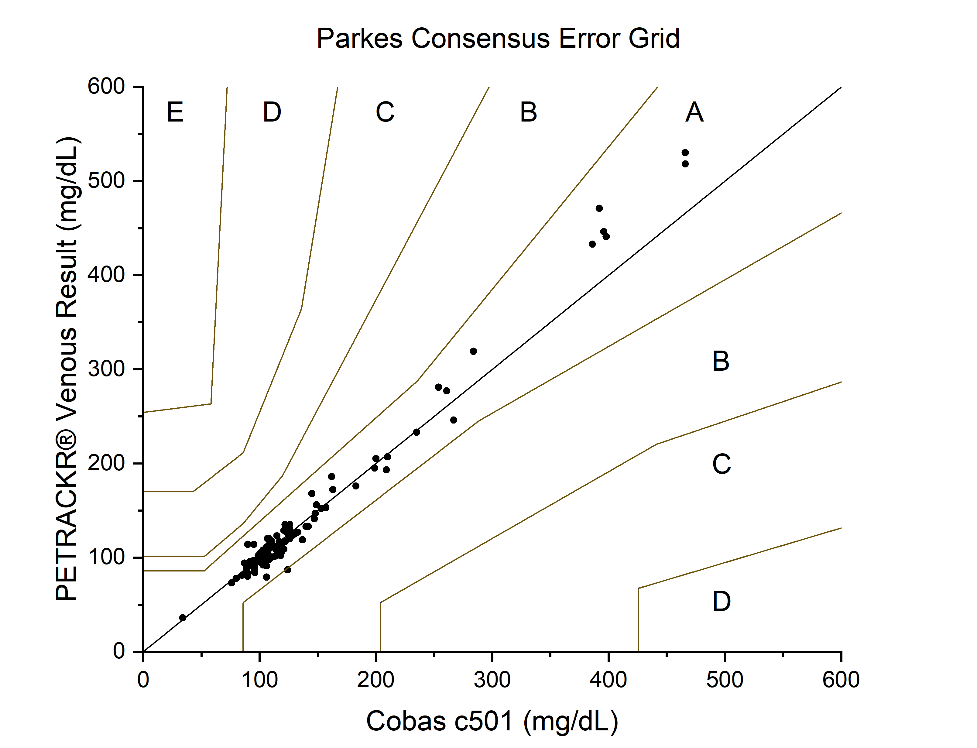
Zone | Risk Profile
A | No effect on clinical action
B | Altered clinical action – little or no effect on clinical outcome.
C | Altered clinical action – likely to effect clinical outcome
D | Altered clinical action – could have significant medical risk
E | Altered clinical action – could have dangerous consequences.
Figure 3 - Parkes consensus error grid superposed on the data gathered in this study. Tabulated is the estimated risk on data falling within a certain zone.
Therefore any inaccuracies exhibited by the system do not pose any risk to patients within the framework provided by the consensus error grid.
- Conclusion
The PETRACKR handheld glucometer provides results that are in accordance with the standards described in ISO15197:2013 for human glucometer products. Inaccuracies observed in the system evaluated by using Parkes consensus error grid demonstrate that all samples provided results that accurately reflected the patient’s blood glucose in the context of their clinical treatment. Therefore the use of this glucometer for POC measurement of cats and dogs blood glucose is well supported in this study.
- Animal Ethics Statement
Animal ethics oversight was provided by the Cornell University Institutional Animal Care and Use Committee (Ref. 2022-0241).

Funding
This study was funded by Universal Biosensors.
- Acknowledgements
We gratefully acknowledge the contributions of the College of Veterinary Medicine at Cornell University and the following support and technical staff: Carol E Frederick LVT VTS (ECC), Andrea L King LVT, Lucinda L. Bennett LVT, Megan L Lussier LVT, Kim Heath LVT, Vicki Weber LVT, Heather Campbell LVT.
- References
[1] D. G. O’Neill, Gostelow, R.; Orme, C.; Church, D. B.; Niessen, S. J. M.; Verheyen, K.; Brodbelt, D. C. (2016) J. Vet. Intern. Med. 30 (4), pp. 964.
[2] Heeley, A. M.; O’Neill, D. G.; Davison, L. J.; Church, D. B.; Corless, E.K.; Brodbelt D. C. (2020) Canine Medicine and Genetics 7(6).
[3] American Veterinary Medial Association website: https://www.avma.org/resources-tools/reports-statistics/us-pet-ownership-statistics. Access date: 14JUN23.
[4] Loftus, J. P.; Wakshlag, J. J. (2015) Vet Med (Auckl) 6:49-60.
[5] Lund, E. M.; Armstrong, P. J.; Kirk, C. A.; Klausner, J. S. (2006) Intern. J. Appl. Res. Med. 4, 177.
[6] Lund, E. M.; Armstrong, P. J.; Kirk, C. A.; Klausner, J. S. (2005) Intern. J. Appl. Res. Med. 3, 88.
[7] Kerr, M. G. (2002) Veterinary Laboratory Medicine Clinical Biochemistry and Haematology Second Edition Blackwell Science: Oxford.
[8] Wolfenden, G.; James, F. E.; Hung, L H. T.; Bruce, M.; Thompson M. (2022) J. Small Anim. Prac. 63 pp. 512.
[9] ISO15197:2013 In vitro diagnostic test systems – Requirements for blood-glucose monitoring systems for self-testing in managing diabetes mellitus. Access date: 20/08/2013
[10] Parkes, J. J.; Prado, S.; Slatin, S. L.; Ginsberg, B. H. Diabetes Care 23 (8) pp. 1143.
[11] Pfützer, A. et al. (2013) J. Diab. Sci. Tech. 7(5) 1275.
[12] Clarke, W. K. et al. (1987) Diab. Care 10(5) 622.

D. G. O’Neill, Gostelow, R.; Orme, C.; Church, D. B.; Niessen, S. J. M.; Verheyen, K.; Brodbelt, D. C. (2016) J. Vet. Intern. Med. 30 (4), pp. 964.
Heeley, A. M.; O’Neill, D. G.; Davison, L. J.; Church, D. B.; Corless, E.K.; Brodbelt D. C. (2020) Canine Medicine and Genetics 7(6).
American Veterinary Medial Association website: https://www.avma.org/resources-tools/reports-statistics/us-pet-ownership-statistics. Access date: 14JUN23.
Loftus, J. P.; Wakshlag, J. J. (2015) Vet Med (Auckl) 6:49-60.
Lund, E. M.; Armstrong, P. J.; Kirk, C. A.; Klausner, J. S. (2006) Intern. J. Appl. Res. Med. 4, 177.
Lund, E. M.; Armstrong, P. J.; Kirk, C. A.; Klausner, J. S. (2005) Intern. J. Appl. Res. Med. 3, 88.
Kerr, M. G. (2002) Veterinary Laboratory Medicine Clinical Biochemistry and Haematology Second Edition Blackwell Science: Oxford.
Wolfenden, G.; James, F. E.; Hung, L H. T.; Bruce, M.; Thompson M. (2022) J. Small Anim. Prac. 63 pp. 512.
ISO15197:2013 In vitro diagnostic test systems – Requirements for blood-glucose monitoring systems for self-testing in managing diabetes mellitus. Access date: 20/08/2013
Parkes, J. J.; Prado, S.; Slatin, S. L.; Ginsberg, B. H. Diabetes Care 23 (8) pp. 1143.
Pfützer, A. et al. (2013) J. Diab. Sci. Tech. 7(5) 1275.
Clarke, W. K. et al. (1987) Diab. Care 10(5) 622.

